实验8 Web性能测试

|  |  |  |  |  |  |  |  |
| --- | --- | --- | --- | --- | --- | --- | --- |
| 组 别 |  | 实验人员 | KAFLE SAMRAT | | | | |
| 实验项目名称 | Web性能测试 | | | | | | |
| 实 验 类 别 | 验证型□ 设计型□ 综合型□ | | | | | | |
| 实 验 工 具 | Jmeter、badboy | | | 实验地点 | J13-132 | 实验日期 | 2020.12.21 |
| 学生实验小结 | 通过使用Jmeter，我发现这是一款很强大的软件，对测试网站的性能有很大的帮助，通过建立线程的方式，对同一个网站进行同时访问，简化了我们操作。还可以通过监听器及时查看访问测试情况，提高测试效率。Badboy对网页操作的捕捉录制也很便利，它和Jmeter配合使用方便我们测试一套完整流程的网页操作，增强了网站性能测试的灵活性。 | | | | | | |
| 教师评语 | 指导教师签名：  年 月 日 | | | | | | |
| 实验成绩 |  | | | | | | |

1实验内容和目标

1.1实验内容

本实验首先熟悉了解Jmeter测试工具的安装，功能，以及使用方法并根据要求使用JMeter模拟虚拟用户代替真实用户。通过数十、数百乃至数千个虚拟用户模仿真实用户的操作来对一个网站进行性能测试，并对测试结果进行分析。

然后，熟悉了解脚本录制工具Badboy的安装以及相关功能，通过脚本录制的方式，生成脚本，并将脚本导入到Jmeter中，借助于Jmeter对一个网站进行性能测试。

1.2实验目标

（1）掌握安装jmeter的方法；

（2）学会使用jmeter对一个网站进行简单的性能测试。

（3）掌握Badboy的安装和使用方法

（4）通过Badboy的脚本录制，结合Jmeter对一个网站进行简单的性能测试

2实验方案设计

2.1实验环境

JMeter+jdk1.8+Badboy

2.2实验方法设计

安装jmeter，了解jmeter基本功能，对中国慕课网进行简单的性能测试，通过badboy脚本录制，结合jmeter对一个网站进行简单性能测试。

实验步骤和结果:

JMeter installation

1. Install JDK. Here I have JDK 1.8 installed on my computer.

2. Unzip the installation package sent by the teacher and open jmeter.bat under the bin directory to install Jemter

3. Open the jmeter

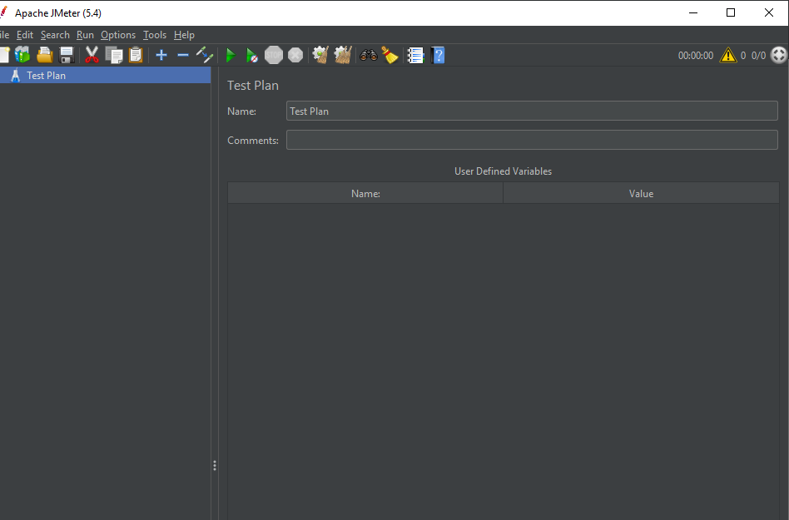

Understand the capabilities of the JMeter tool components

1. The test plan is used to describe a performance test, including all functions related to the performance test. This means that everything in this performance test is based on a plan. Right-click Test Plan to pop up the menu

2. Thread Group represents a certain number of concurrent users, which can be used to simulate concurrent users sending requests.

3. The Sampler (Sampler) is sends a Request to the server in the performance test, record the response information, record the smallest unit of response time, JMeter native support for different types of Sampler, such as HTTP Request Sampler, FTP Request Sampler, TCP Request Sampler, JDBC Request Sampler, each a different type of Sampler can according to set parameters of different types of requests to the server

This Listener is not a component used to listen for system resources. It is a series of components used for processing and visualization of test results data. Graphing results, viewing result trees, aggregating reports, and viewing results in tables are some of the most common components we use.

Logic Controller includes two kinds of no-parts. One is the Controller used to control the logical order of sending requests by Sampler node in Test Plan. The commonly used ones are IF Controller, Switch Controller, Runtime Controller, Loop Controller, etc. The other type is used to organize nodes that can control Sampler's incoming nodes, such as transaction controllers and throughput controllers.

3.3 Conduct a simple performance test for China MOOC

1. Add a thread group

2. Add HTTP requests

3. Set QPS limits

4. Add listeners

5. Run the script to see the results

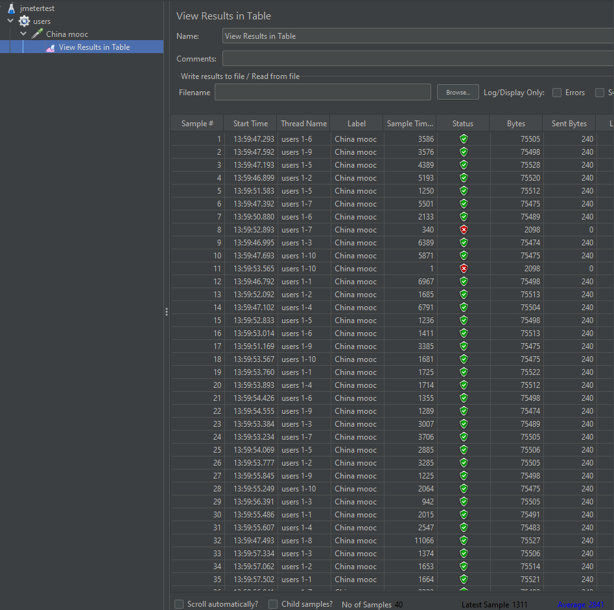

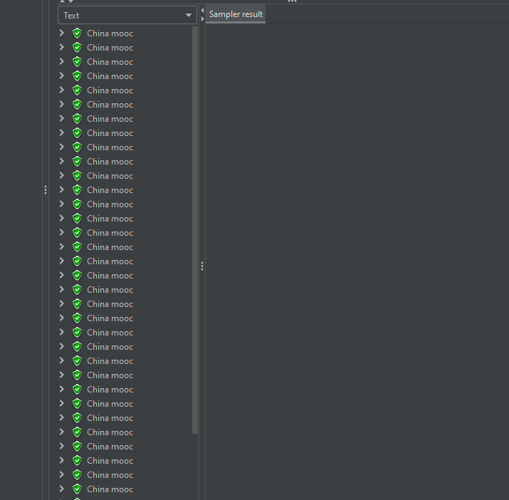

Install badboy

1. Download the compressed package issued by the teacher, unpack the Badboy installation package, and install it

2. Open Badboy, use Badboy to record the script, test the 360 search and click File in the upper left corner to select Export to JMeter and save it as a.jmx File.

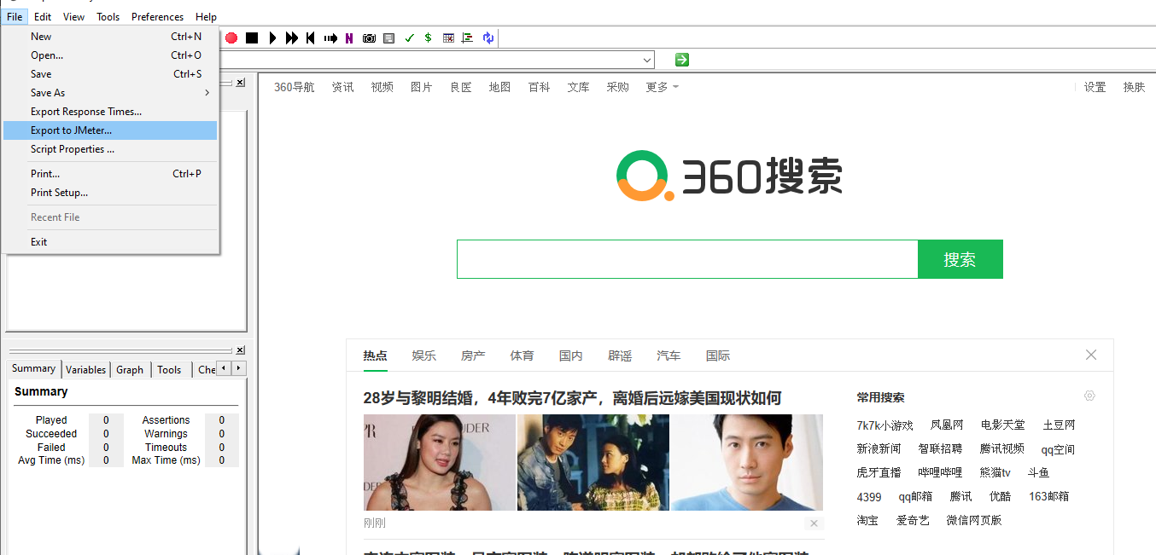

3. Save the.jmx file in the backups folder in the root directory of JMeter

Combined with JMeter to perform a simple performance test on the recorded script

1. Use jemter to open the backups folder in the root directory of jemter and select search.jmx

2. Set 100 threads with loop control of 1

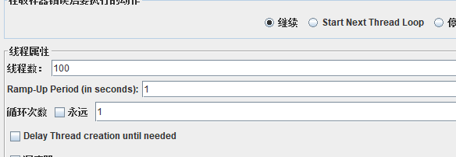

3. Add listeners to view aggregate reports and graphical results

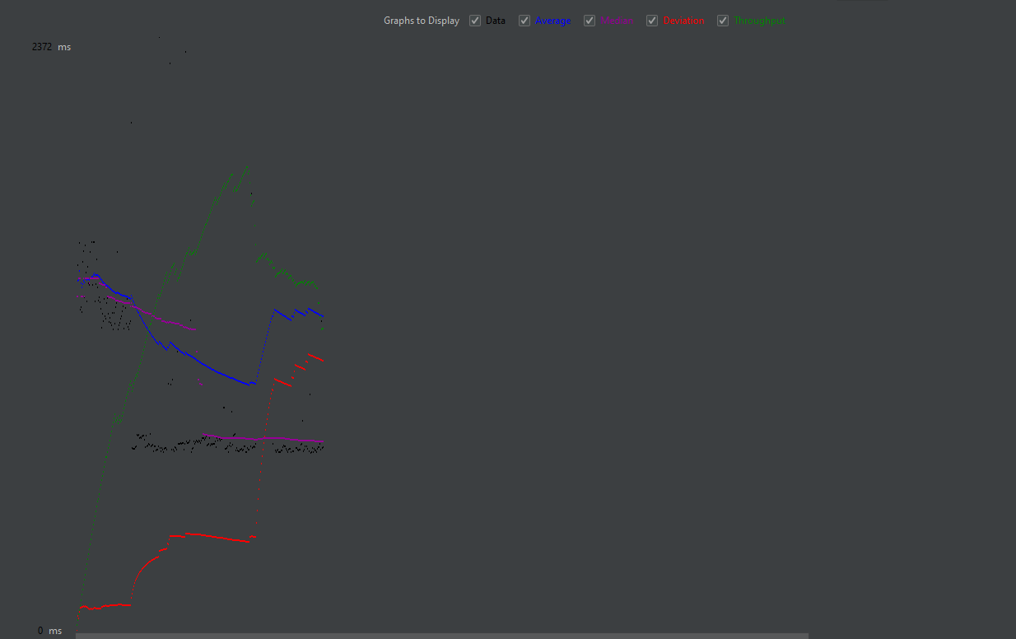

JMeter was used to test the performance of Taobao.com and Jingdong

1. Add a timer, set to 1200, add a listener to view the result tree, aggregate the report, view the results with a table, etc., to record the running status and results

For jd.com

Tree report

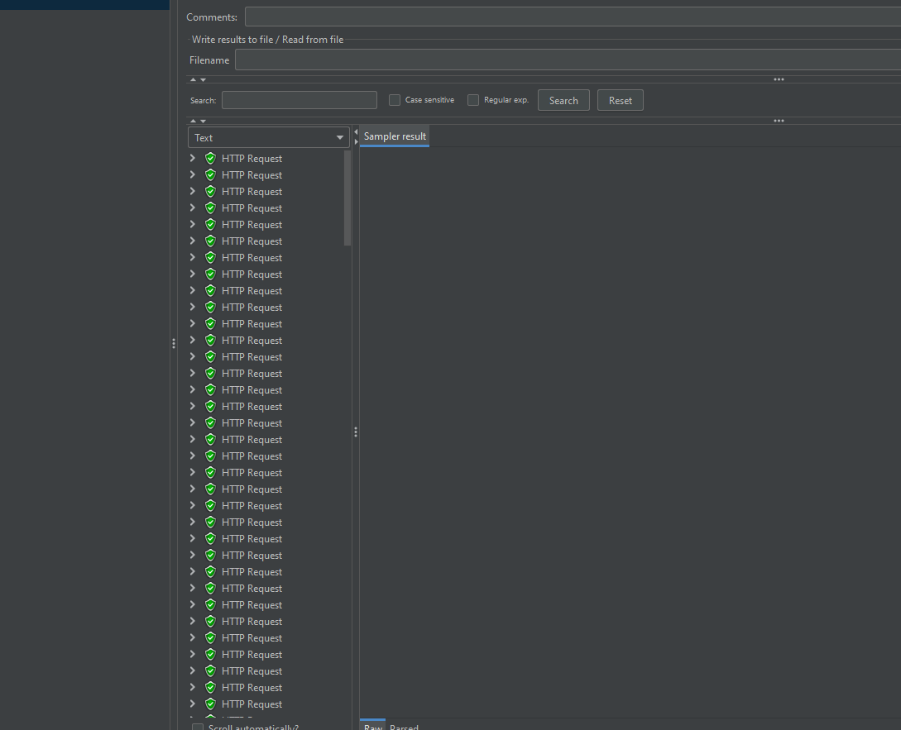

Aggregate report

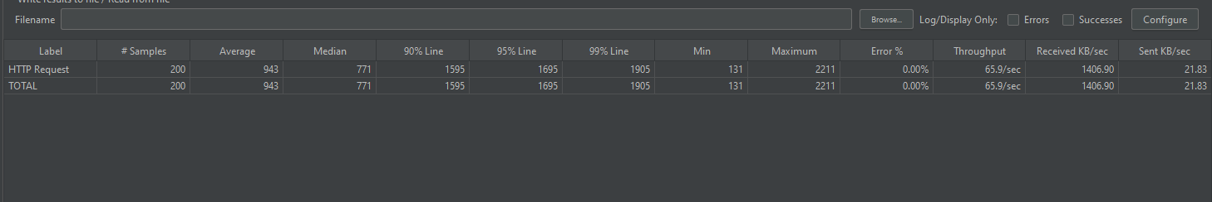

Summary report

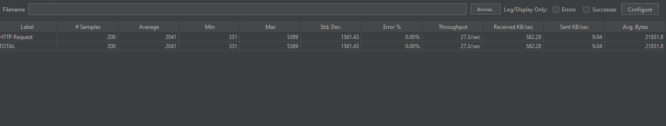

Graph report

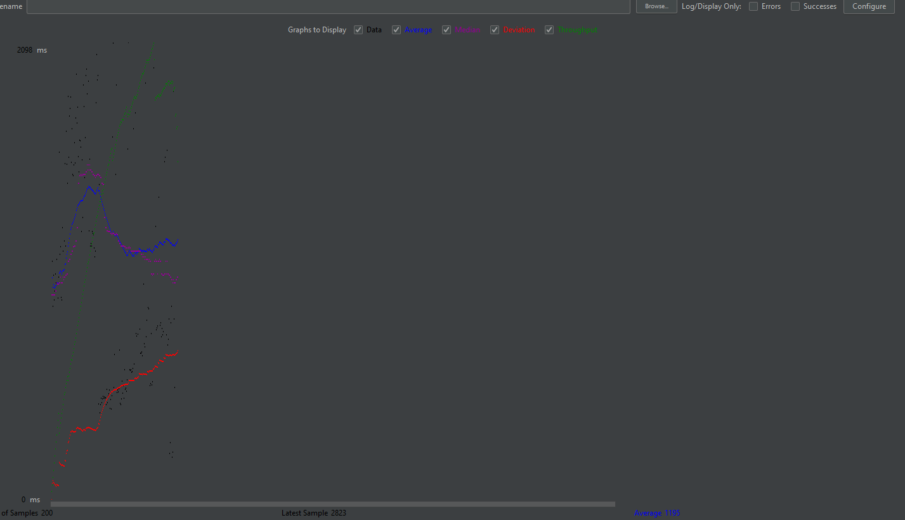

Report in table

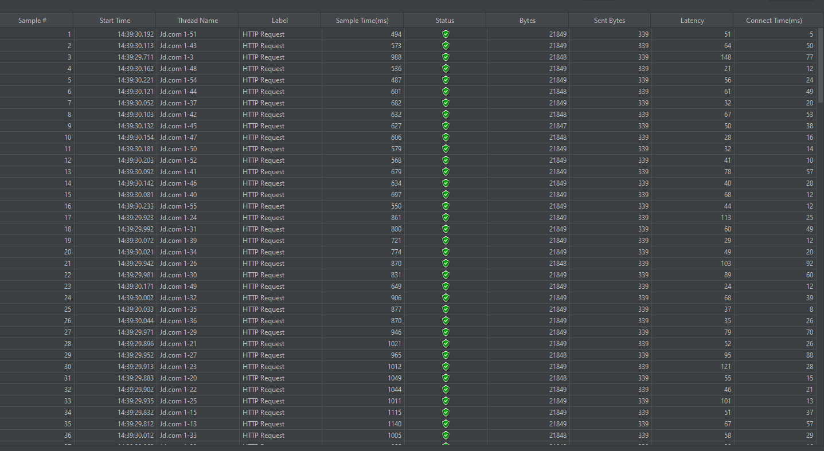

For Taobao.com

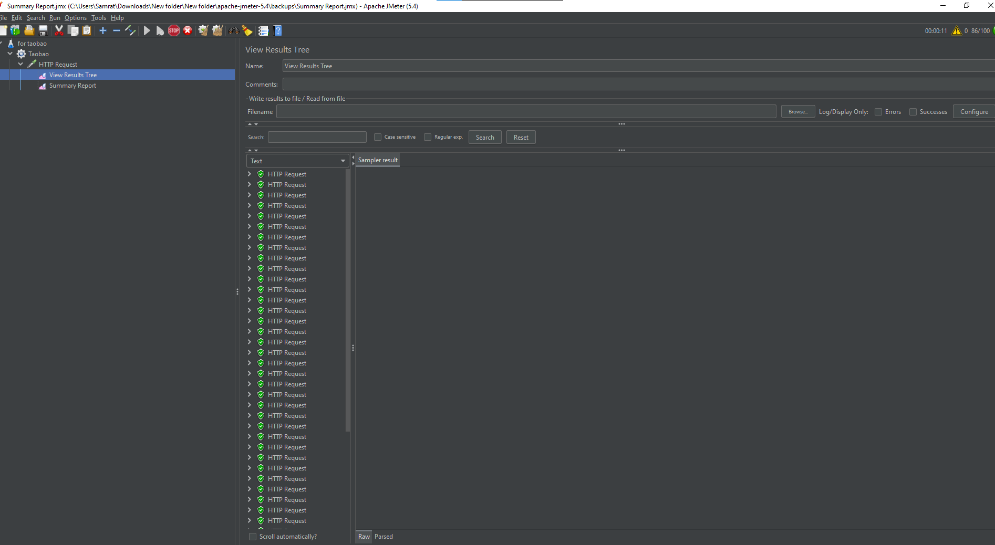

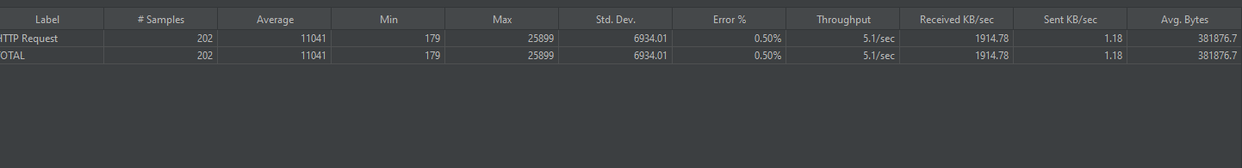

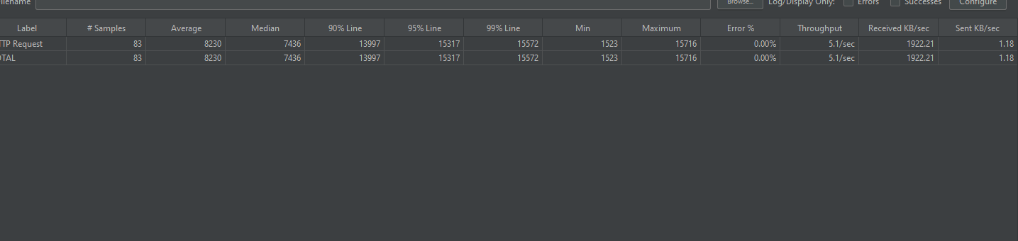

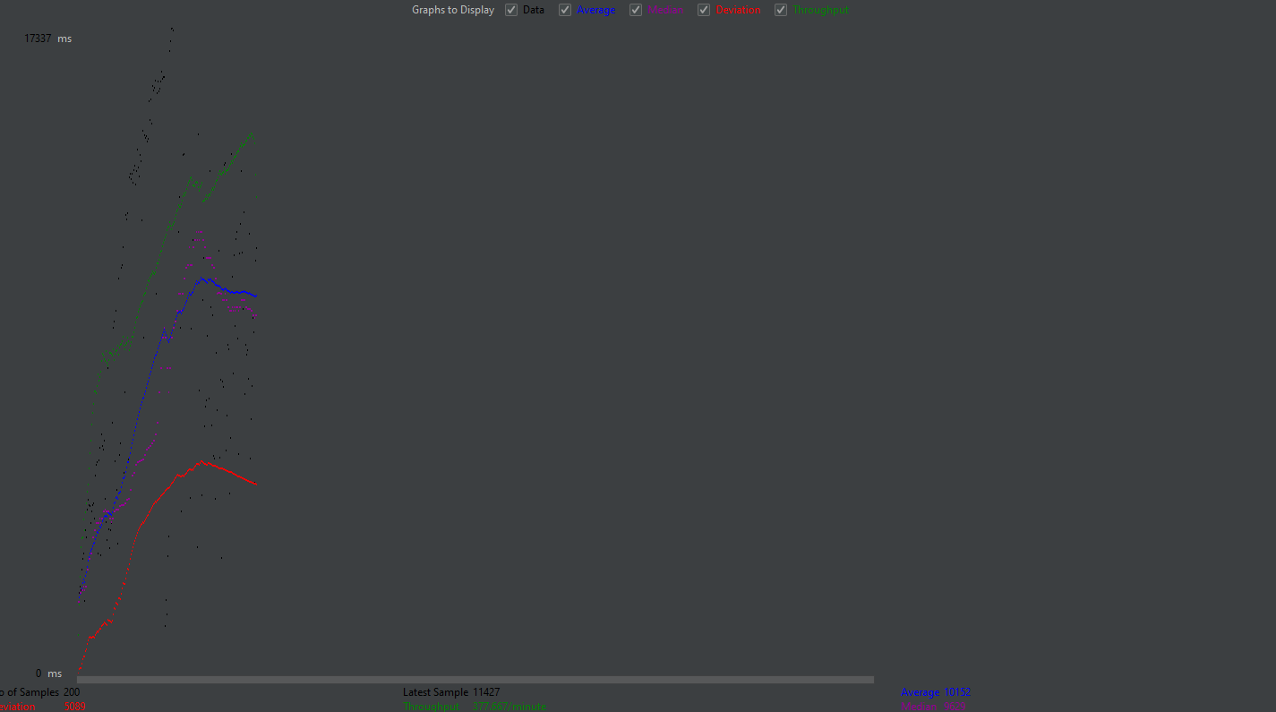

实验结果分析

通过使用Jmeter，我发现这是一款很强大的软件，对测试网站的性能有很大的帮助，通过建立线程的方式，对同一个网站进行同时访问，方便了我们操作。还可以通过监听器及时查看访问测试情况，非常方便。Badboy对网页操作的捕捉录制也很便利，它和Jmeter配合利用方便我们测试一套完整流程的网页操作，增强了网站性能测试的灵活性。